*Creates a Risk Management Plan for the Fox Islands Wind Project Case.*

**Assignment**

**2**

A2

ALY6005 Project Scope Management

Assignment 2 – Individual Assignment (RMP)

**PREPERATION:**

By: John DiSessa

For: Professor Gray

On: November 16th, 2022

Executive Summary

A Requirements Management Plan (RMP) “describes how project and product requirements will be analyzed, documented and managed.”2 This RMP, for the Fox Islands Wind Project, summarizes the case, conducts key stakeholder analysis via a power interest grid, lists the most relevant requirements collection methods, and concludes with a collection timeline. This RMP will provide a succinct summary of the key issues, stakeholders, and project requirements for the Fox Islands Wind Project.

Project Overview

The Fox Islands are made up of two towns, Vinalhaven and North Haven, located off the coast of Maine. In the middle of the West Penobscot Bay, the only way to reach the islands is via an hour-long ferry ride from Rockland. As an isolated community, residents have struggled to get affordable electricity. Before the Fox Islands Wind Project, residents paid about three times the national average for electricity delivered via a 10-mile long umbilical cord connected to the mainland. George Baker, a seasonal resident and Harvard Professor, saw the need for cheaper electricity for residents as well as the necessity to break away from their dependency on Fox Islands Electric Cooperative, who operated as a regulated monopoly. He became CEO of Fox Islands Wind LLC to lead the project to build wind turbines on the islands. Met with many obstacles, Baker took creative approaches to financing, construction, and most importantly, community support and involvement.

Stakeholder Analysis

A stakeholder is “an individual, group, or organization who may affect, be affected by, or perceive itself to be affected by a decision, activity, or outcome of a project.”2 The first step to stakeholder analysis is identifying all of the individuals and organizations that could be affected by this project. In the table below, we listed 15 relevant stakeholders.

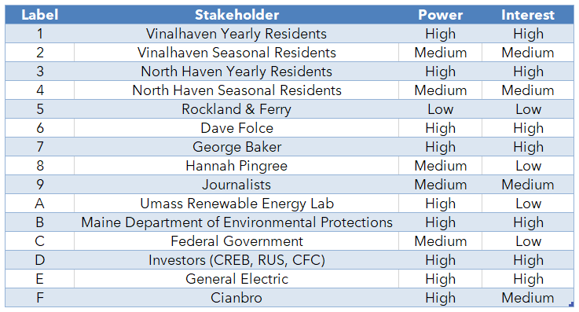

The next step, and key to stakeholder analysis, is finding a balance between including all parties that need to be involved and giving the right amount of influence accordingly. We accomplished this by creating a power-interest grid so that we can prioritize our stakeholders effectively. Stakeholders with high power or influence over the project are at the top of the y-axis and those with low power or influence are near the bottom of the y-axis. Stakeholders that are very interested in, or will be greatly affected by the project, are to the right of the x-axis. Those with little interest, or will not be that affected by the project, are to the left of the x-axis. In correspondence with the previous table, we plotted power and interest together to create an overall visual summation of their relative importance as a stakeholder. To make the chart easier to interpret, we assigned numbers and purple circles to the stakeholders that are recognized as individuals. The grey circles with letters are stakeholders that are companies or corporations. We felt it was important to distinguish between these two types because the communication channels and funding levels can differ between these two groups.

The stakeholders in the red section are the most important stakeholders to consider for the project since they have both high influence over the project success and will be significantly affected by the project outcome. The stakeholders in the green section are the least important stakeholders. While these stakeholders should not be totally ignored, they have the least amount of power and interest in the project. Stakeholders in both of the yellow sections have varying amounts of power and interest. These stakeholders should be given a medium level of importance since their combinations of power and interest make them significant stakeholders but not as crucial as those in the red section.

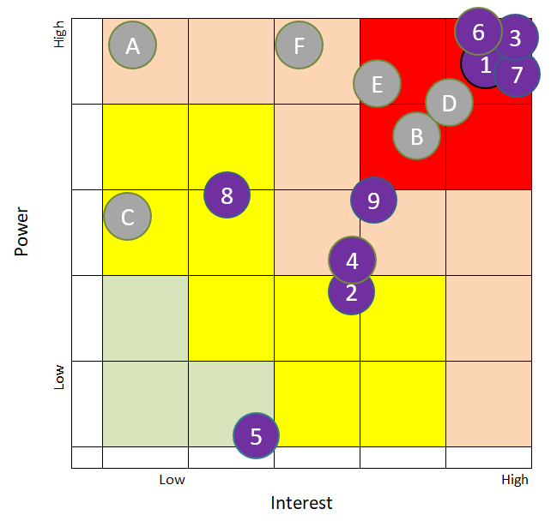

Requirements Collection Methodology

There are various project requirements that need to be met for a project to succeed. They can range from business requirements to stakeholder requirements to technical or functional requirements. The Fox Islands Wind Project case expressed requirements from all 3 of those categories. What was more exciting, however, was how George Baker and others went about collecting the requirements. There were 6 different methodologies that the teams used as expressed in the table below. The table shows each methodology’s pros and cons as well as how it was actually used in the Fox Islands Wind Project case.

|  |  |  |  |
| --- | --- | --- | --- |
| **Methodology** | **Pros** | **Cons** | **Project Implementation** |
| *Brainstorming* | Quick & cheap | Relies on creativity from experts & non-experts | Creative Project & Financing Ideas |
| *Interviews* | In-person, more in-depth answers | Open to bias and may be unrepresentative from small sample size | Local Journalistic Reporting |
| *Document Analysis* | Formal and good for record keeping | Time consuming | Financial Proposals & Wind Turbine Efficacy Analysis |
| *Observation* | Learn from previous mistakes & get realistic feedback | Could be unique circumstances that are not applicable | Cape Cod Wind |
| *Focus Groups* | Determine community sentiment & get direct feedback | Skilled moderator needs to keep everyone focused on the key issues | Town Halls with Residents |
| *Requirements Workshop* | Creates a mutual understanding | Key stakeholder analysis must be accurate | Open & Direct Communication with Stakeholders |

Collection Timetable

With these 6 requirement collection methodologies, they will all happen on varying timetables. First, it is unfeasible for a project to use all of these methods at the same time. There can be some overlap but it is more effective to gather requirements over time to avoid overwhelming project stakeholders. Second, each methodology has its own unique way of gathering information. Third, different methodologies require speaking with different stakeholders. Each stakeholder can become involved in the project at different times from one another. The collection timetable below lays out a plan to accommodate all stakeholders while being mindful of limited project resources. The left side of the large, light-blue arrow, represents the start of the project while the end of the arrow represents the end of the project. Each methodology can start and end at different times during the project and each methodology can also last a different amount of time than other types of methodologies.

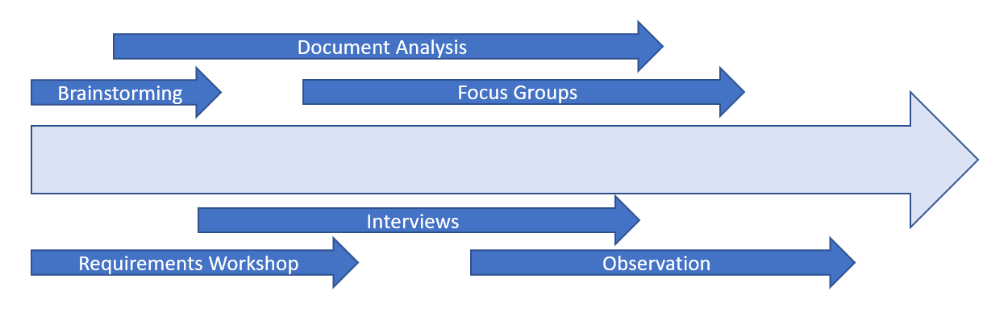

Collection Timetable

1 “The Fox Islands Wind Project (A).” Harvard Business School, 15 Feb. 2001.

2 Gray, Laura. “PJM6005: Project Scope Management.” *Week 2: Collecting Requirements Slides*.